A crisp Visuals views of Digital SCR System Map – Desktop/Mobile based TMS systems digitally mapped for ZB - HBU Section A POC
S.no | Screen Shots of Digital SCR System Base Map for SC Division/HYB Division integrated and overlaid on Google/OSM map layers for navigating Linear Assets on ground duly digitized on !:2000 scale with environment Intelligence surfaced – Value add of MMIS Tech. | Brief description of individual screen and advantages for Engineer Strategists of SC Division.  Advantages and value add to users explained
1. | 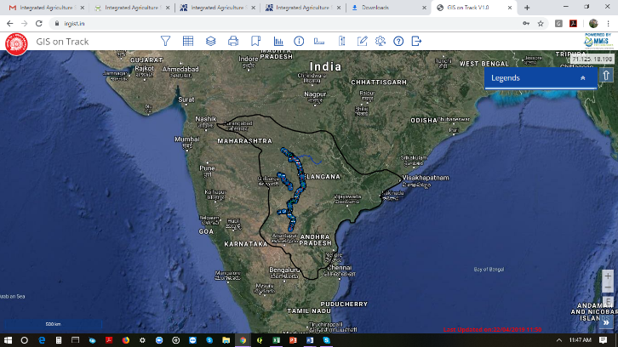 | - Overview of VKB-HBU & HYB Division on Google Map  - All linear assets as per TMS are mapped  - Bridges, Level crossings, Railway Station, Index plans etc. are positioned on ground.
2. | 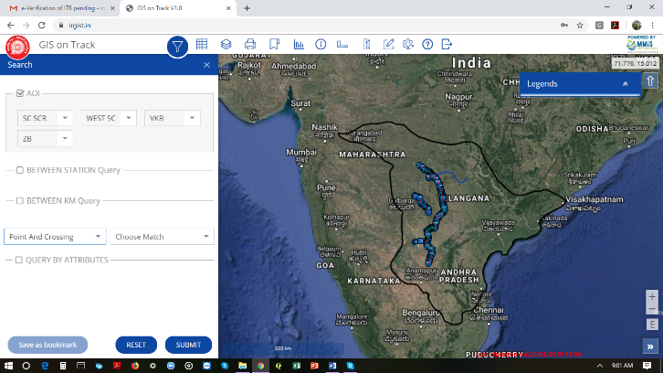 | - Functionalities on top – Search, Attribute grid, layers, print, Book mark, Dash Boards, Info tool, Area and length measurement tool, help and logout.  - Search to reach and view layers of interest i.e. LC, Bridges etc with boomark record facility  - Which can be clicked to create d and save view of site and work
3. | 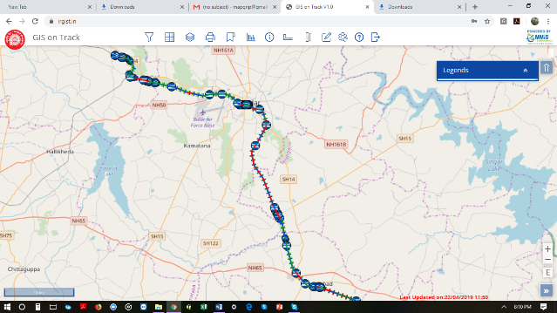  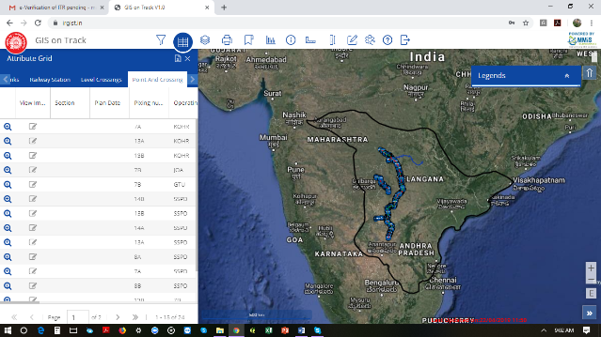 | - Attribute grids the (Excel data of TMS) is being displayed on left side for all linear assets with following features for ZB - HBU  - Whole TMS data are shown separately under each class of linear assets  - In the view it is Points & Crossings  - Zoom lens will navigate to particular location of asset geo-coded from the MMIS systems w/o filed survey  - In this case Point and crossing of location is navigated with legend

4. | 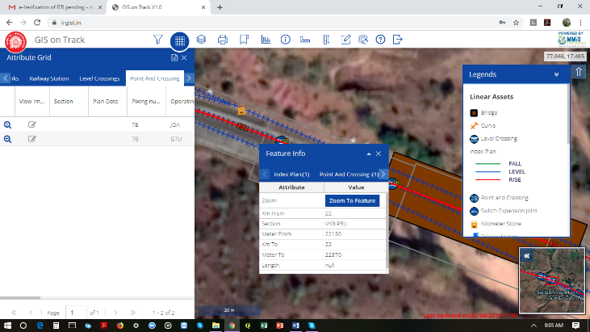 | - VKB – ZB - Linear Assets  - On click of Point and crossing with selection of info tool a pop up would display details of asset correspondingly on to the right wherein, select data fields from the TMS systems are displayed  - This process shall work to all linear assets mapped in the product  - What viewed in map is displayed on excel sheet not all assets  - It filters to ground views of all assets seen in screen viewed by panning on pop-up on screen.
5. | 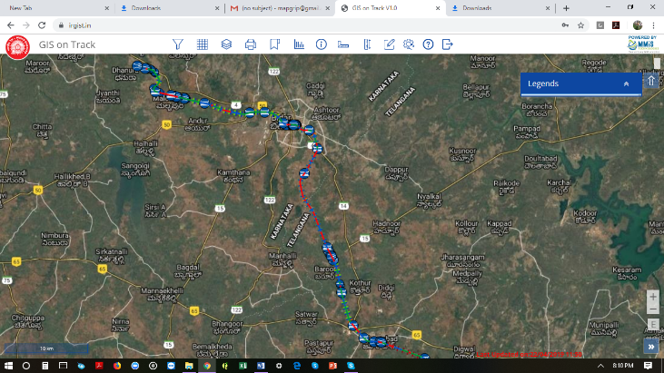 | - ZB-HBU SECTION ON GOOGLE  - Linear Assets can be conveniently switched on/off as per functional roles of Engineering personnel  - Linear Assets can be layered in permutations and combinations as per functional need and analysis  - In current view all layers are off and rail track, KM stones and Land boundaries are on 50km top view
6.  7. | 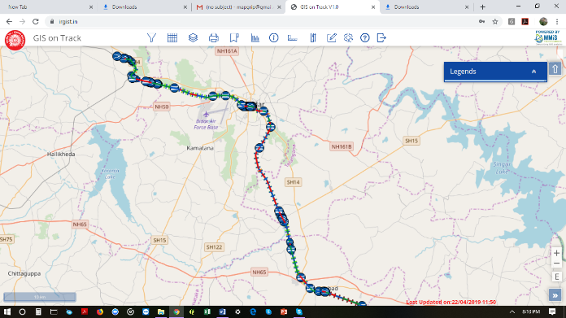  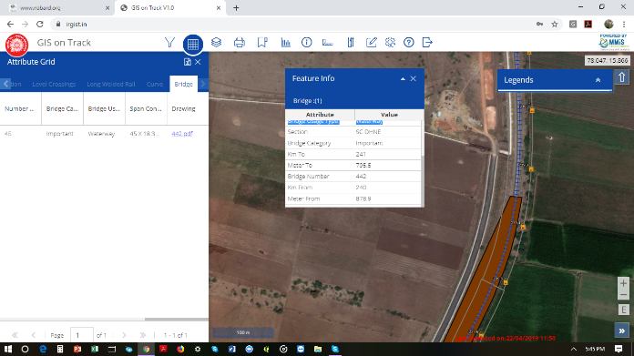 | - For SC – Division of SCR Zone facility overlay to view districts/sub-districts names and OSM/Google on SCR Base Map  - Base map is supported by Railway Running tracks and its actual surrounds  - TMS data is geographical representation of Linear Assets represented in excel sheet  - IR – GIST re-orients TMS data geographically where it is originated from on ground as it looks on fly  - Seen in Fig. 7 bridge location from TMS on ground pictured through Base Map SCR Digital System Map as Google over lay  - Bridge polygon digitized displayed  - KM Stones and Land Boundaries are also visible  - Bridge details Popup seen  - Drawings and other important data is attached ensuring Digital Systems are effectively used making practical paperless.

8. | 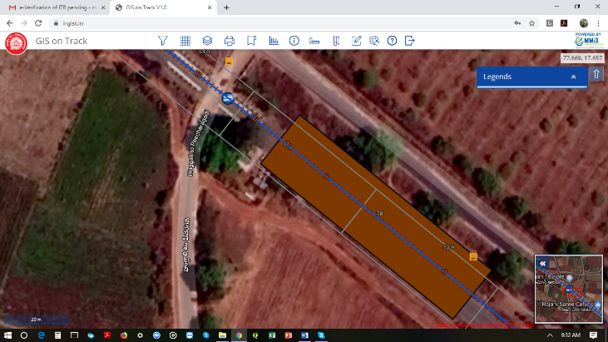 | - As an eg. We can see bridge whole updated data is displayed on click  - Land boundaries KM stone (Hecto Meters) as per TMS can be viewed a record of TMS of Bridges  - Through Mobile Edit Module (Ver.2.0) bridge attributes photos on work progress details made available.
9. | 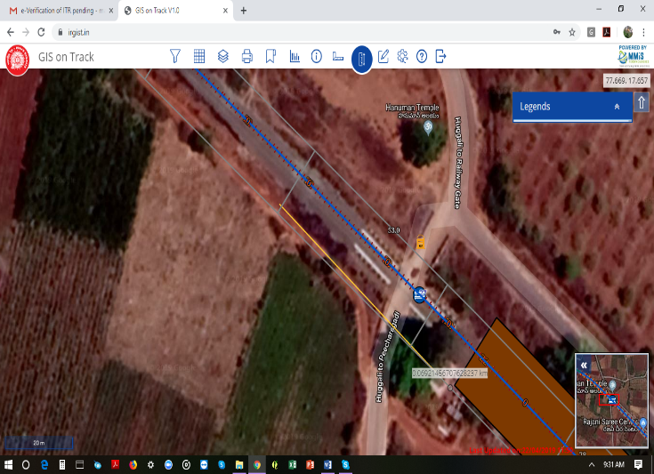 | - Tools provided to  - Length Measurement tools – can see (Fig. 9) Icon is highlighted and yellow line along bridge is seen and display of bridge length is also seen.  - Length Measurement tool can be used to user context for various functional needs on fly.
10. | 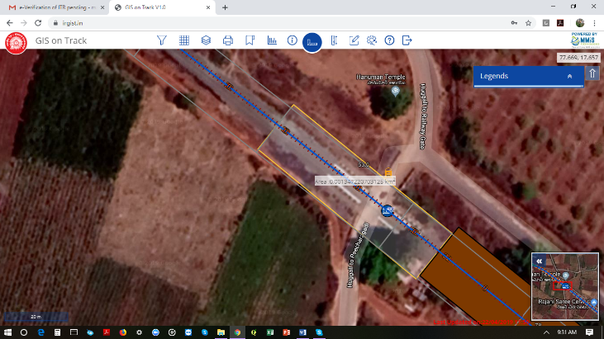 | - Area Measurement Tool used to calculate closed areas such as site area location man, water bodies, station yards and boundaries.  - In Fig. 10 we can see area of the bridge is done by clicking at point of bridges and area shown as KM².  - Map Update tool shall help to create user id specific layers and create labels for managing the scheduled works execution through plans  - Digital Note Book for Field personnel to update reports directly through mobile  - Dash boards of operations plans vs. actual and guide plan activities scheduling – can be perfected to Pocket based ERP systems.

11. | 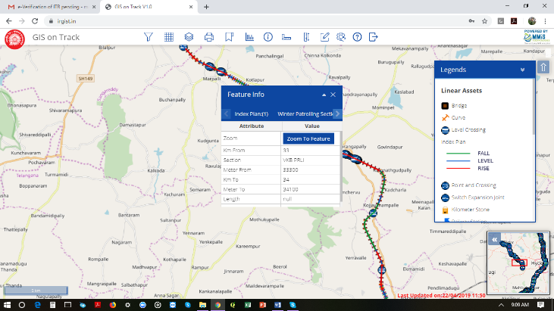 | - Every linear assets cab be viewed on a click  - Corresponding legend and thumb nail view with lat/longs communications in view comprehensively help environment  - Edit features provided in mobile make work updated and simple.  - Complex data sets demystified
12. | 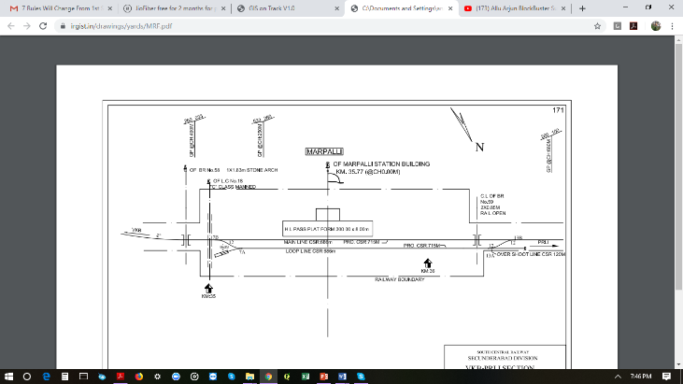 | - Down load of drawings and photo images are provided  - Image of each assets can be uploaded  - Updated photo/pdfs docs shall ensure linear asset related drawings noting etc.  - Facility upload updated drawing
13. | 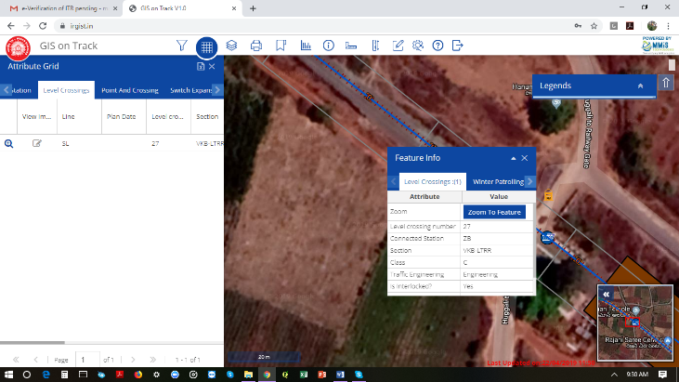 | - Spatial features selection and identification through Google  - Draw boundaries  - upload to pictures  - Geo-tag created assets on frequent intervals  - Google/Bhuvan imageries integrations making Digital Atlas special and effective for planning and management.

14. | 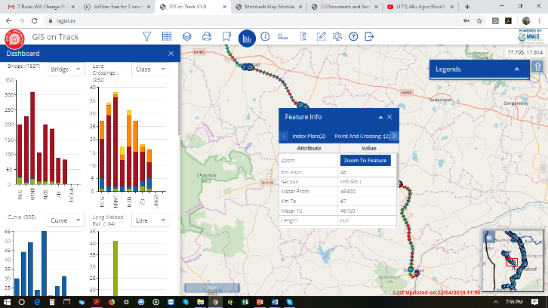 | - Dash boards of linear assets representing count and classes of assets section wise
15. | 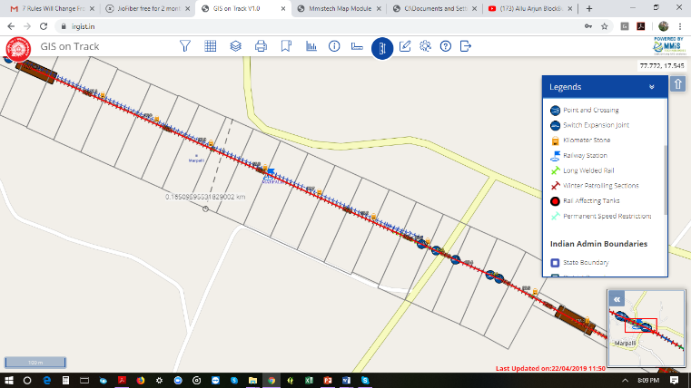 | - Railway boundaries developed from TMS system is unique feature a base control points  - Updates and shifts can be updated through edit module  - Mobile based edit feature capture GPS co-ordinates to draw and adjust correct boundaries.
16. | 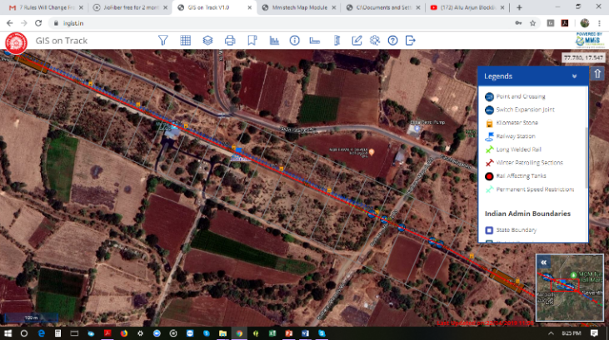 | - Google Integration is a powerful map based input  - Helps to understand the assets of railways and enrolments  - Working on Map based TMS shall throw a new insights of TMS data and help to have better control and understanding of maintenance of linear assets more scientifically on fly.

Se

Section – B Mobile Based SC Division VKB – HBU section
S.no | Screen Shots of Digital SCR System Base Map for SC Division/HYB Division integrated and overlaid on Google/OSM map layers for navigating Linear Assets on ground duly digitized on !:2000 scale with environment Intelligence surfaced – Value add of MMIS Tech. | Brief description of individual screen and advantages for Engineer Strategists of SC Division.  Advantages and value add to users explained
1 | 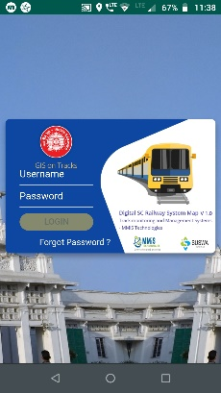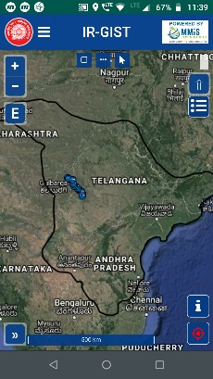 | - Overview of VKB-HBU & HYB Division on Google Map  - All linear assets as per TMS are mapped  - Bridges, Level crossings, Railway Station, Index plans etc. are positioned on ground.
2 | 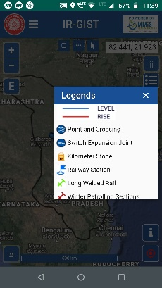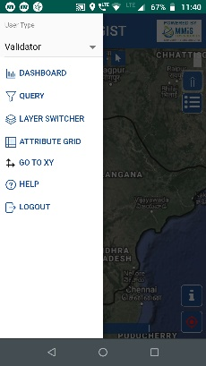 | - Functionalities on top  - Filter  - Attribute (TMS) data excel  - Layers views (23) on/off check layers  - Print module  - Book Mark  - Dash Boards  - Info tool  - Area/length measurement  - Help and logouts
3 | 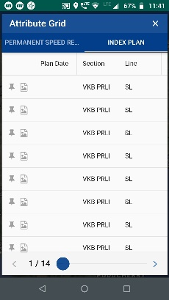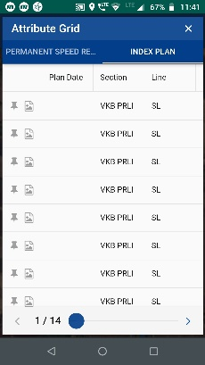 | - VKB – ZB view on fly with linear assets of TMS mapped  - Total lengths of 0-64 KM route viewed from top at 200km on OSM  - Can see villages/towns along track side  - Below when zoomed in we can be Railway boundaries prepared from TMS data  - Legend displayed when selected to understand the feature under display  - Thumb nail view on right bottom can be seen  - Shall help to know the railway land

4 | 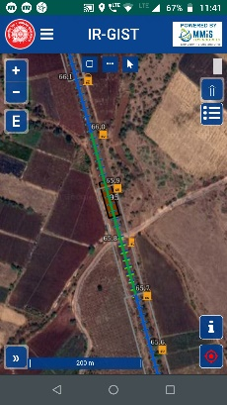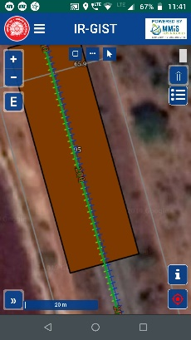 | - .
5 | 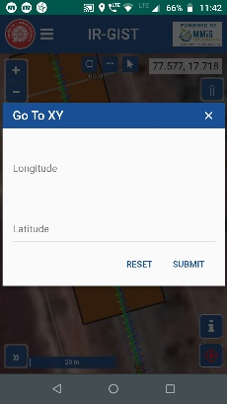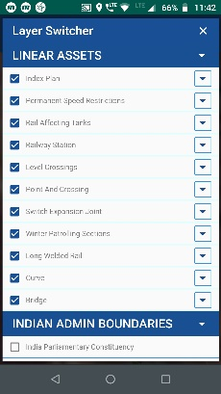 | - Upload pane has two sections  - Non-spatial - can down load templates up to block level by logical drill downs  - can copy and paste parameters (Columns data)  - Spatial Data (Map data shape files  - Parameters can be crated upto 300 columns for visualisation and analytics on fly  - can copy and paste from excel sheet in the box and description of the file can be had  - Need to check the parameter check box if manually created.  - Parameters are individual columns
 | 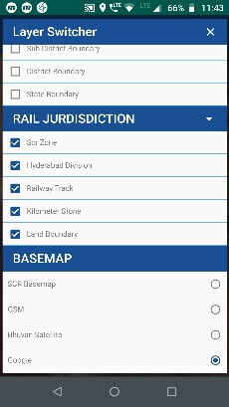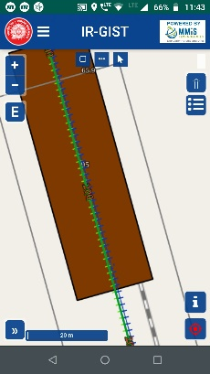 | - Once parameters are created either in manual mode or copy paste mode  - Check for down load and file get saved in default downloads  - Downloaded excel sheet consists parameters and geographic locations  - The data in it has to be copied in template for instant visualsations  - Below is the template created for Alwar district of Rajasthan blocks

7 | 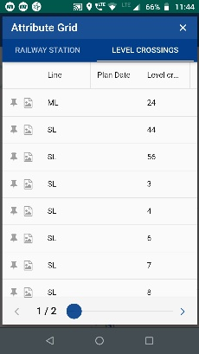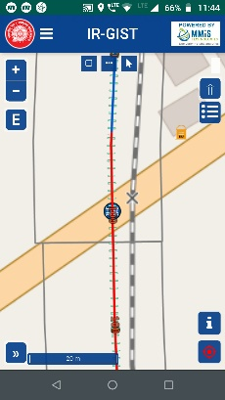 | - A template consisting of five parameters assumed with respect to Agro climatic conditions of the blocks are created  - Absolute date to be copied and pasted for instant analytics of Excel sheet data  - The columns can be between 1 to 300  - Not to change standard template value else output would be erroneous
8 | 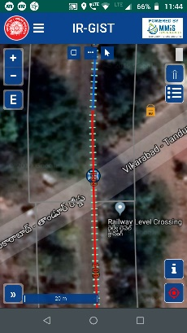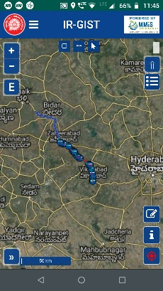 | - Can view of Alwar Blocks of Rajasthan District  - on left side you have parameter window to select each column views  - Absolute data is classified in four ranges  - helps to see the penetration and focus areas to adress  - Helps to understand the program progress on fly
9 | 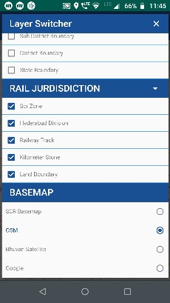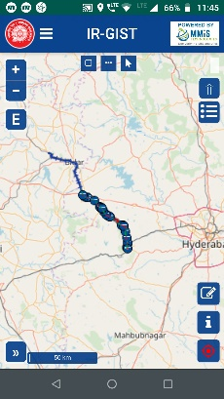 | - As the absolute data changes the colour also get changed and can go classified up to seven ranges  - Back ground is real time Google Road layers getting stemed  - legends have been provided to understand the situations at each block (8&9) variations can be seen  - Each column data can be viewed on fly for immediate comprehension of the programs progress.
10 | 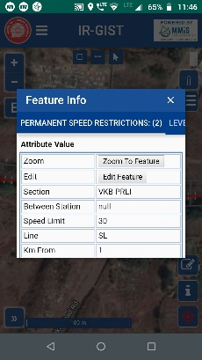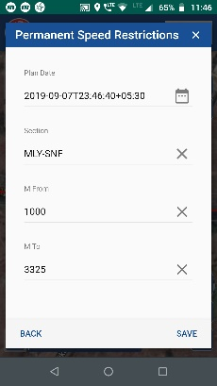 | - Google Imagery overlaid  - can also integrate classified imagery of Bhuvan i  - Environment Intelligence spur helping take better informed decisions on fly  - Provision to insert satellite imageries classified data sets of different themes such as land use/cover, water bodies and streams and canals data  - Helps to take better informed decisions more scientifically on fly complex decisions made simple

11 | 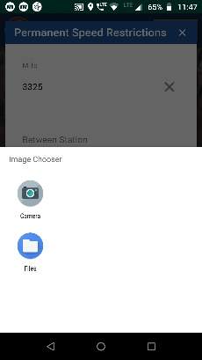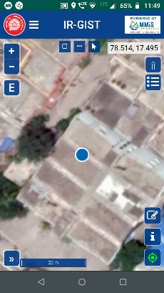 | - Provision to have Map based MIS reporting with notes and decisions  - user can write his notes and club to map views  - Excel sheet uploaded can be downloaded from the application  - Green Technologies auto compliance  - Excel sheet downloaded gets saved in downloads
12 | 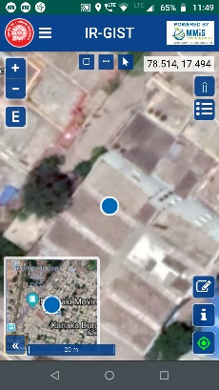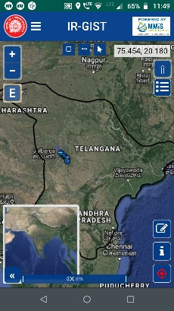 | - Analytics of multiple excel sheet through multi layer analysis  - Enable to plans into frame work and compare variations as time progresses for having visual views and controls  - Styler feature enable user to change colour pattern and ranges of choice to have contextual views of plans and progress of the assignments
13 |  | - Product Digital Atlas has accommodated all features functionalities to have whole of MIS all forms integrated and managed in one frameworks  - Our research has revealed that it is one point of strategic solution spot and very handy for administrators to monitor plan and actual  - Many features are built across that can be introduced as usage is optimal
14 | 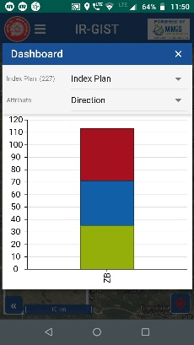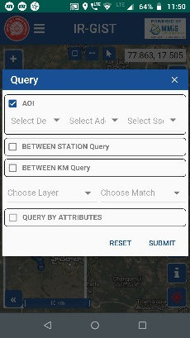 | - Spatial features selection and identification through Google  - Draw boundaries  - upload to pictures and videos  - Geo-tag created assets on frequent intervals  - Google/Bhuvan imageries integrations making Digital Atlas special and effective for planning and mgmt

